## 

## **Experiment-2**

**Student Name:** Gauri Prabhakar **UID:** 18BCS6201

**Branch:** 18AITAIML-2 **Section/Group:** B

**Semester:** 7 **Date of Performance:** 25th August, 2021

**Subject Name:** Advanced Database Management Lab **Subject Code:** CSP - 434

# Aim/Overview of the practical:

To implement DCL, create a user in Oracle Database and then grant and revoke privileges and then implement TCL Commit, Savepoint and Rollback commands.

# Task to be done:

To implement DCL, create a user in Oracle Database and then grant and revoke privileges and then implement TCL Commit, Savepoint and Rollback commands.

# Steps to be followed:

**Create a user identified by a password:**

1. CREATE USER BETA IDENTIFIED BY "beta";

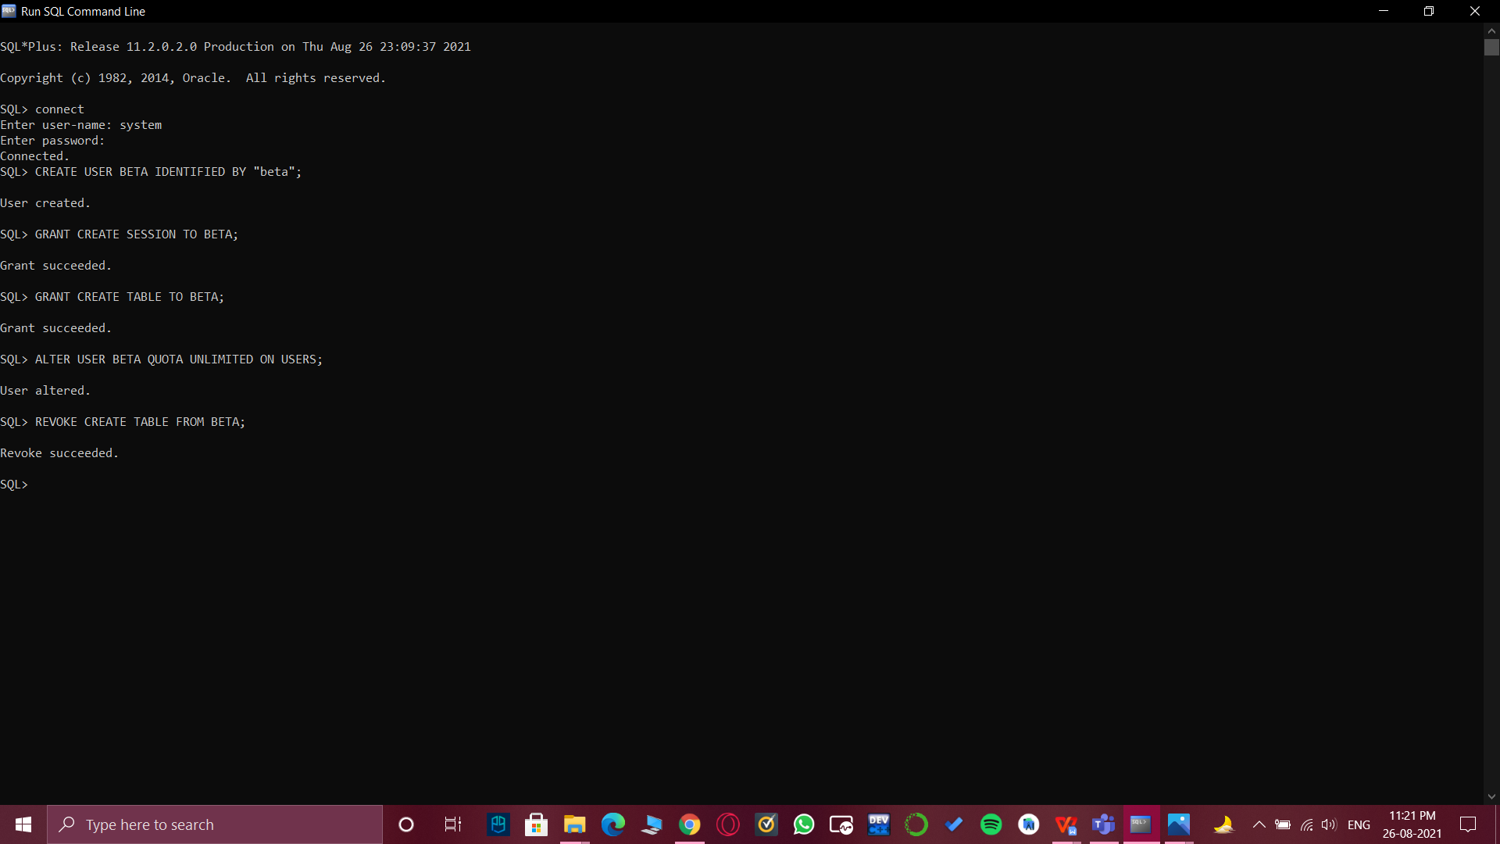

**Grant Create Session and Table access to the user:**

**2.** GRANT CREATE SESSION TO BETA;

GRANT CREATE TABLE TO BETA;

ALTER USER BETA QUOTA UNLIMITED ON USERS;



**Creating a Table and Inserting Values into the Table:**

# CREATE TABLE STUDENTS(Roll_No int, Name varchar(50), Age int);

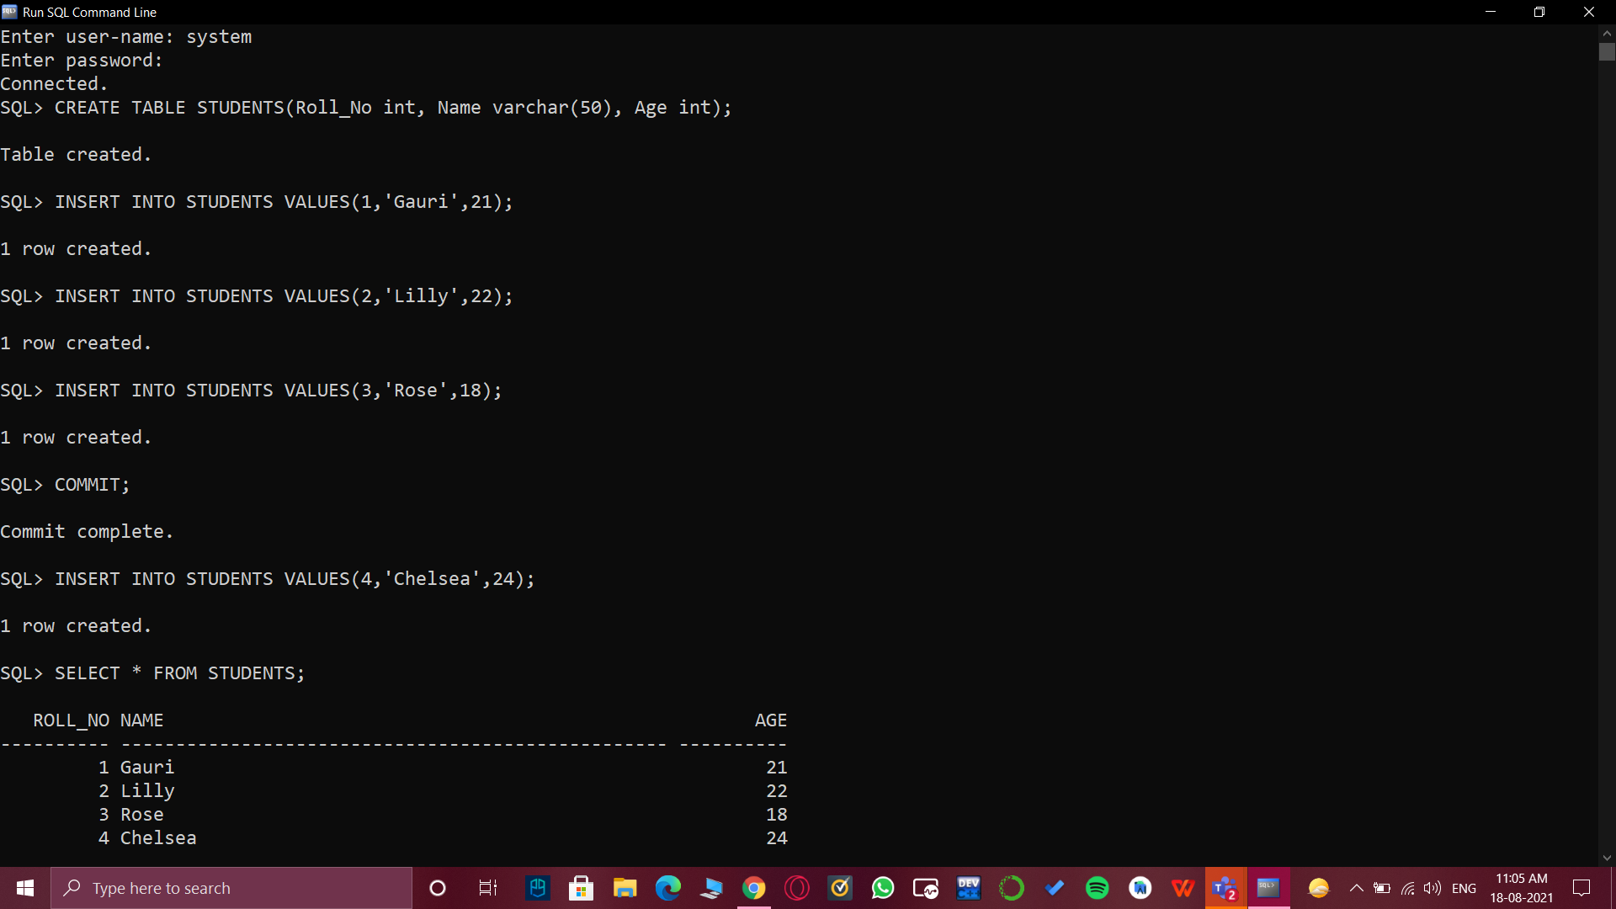

1. INSERT INTO STUDENTS VALUES(1,'Gauri',21);

INSERT INTO STUDENTS VALUES(2,'Lilly',22);

INSERT INTO STUDENTS VALUES(3,'Rose',18);



**COMMIT Values into the table:**

1. COMMIT;



1. INSERT INTO STUDENTS VALUES(4,'Chelsea',24);

SELECT * FROM STUDENTS;



**ROLLBACK to the table:**

1. ROLLBACK;

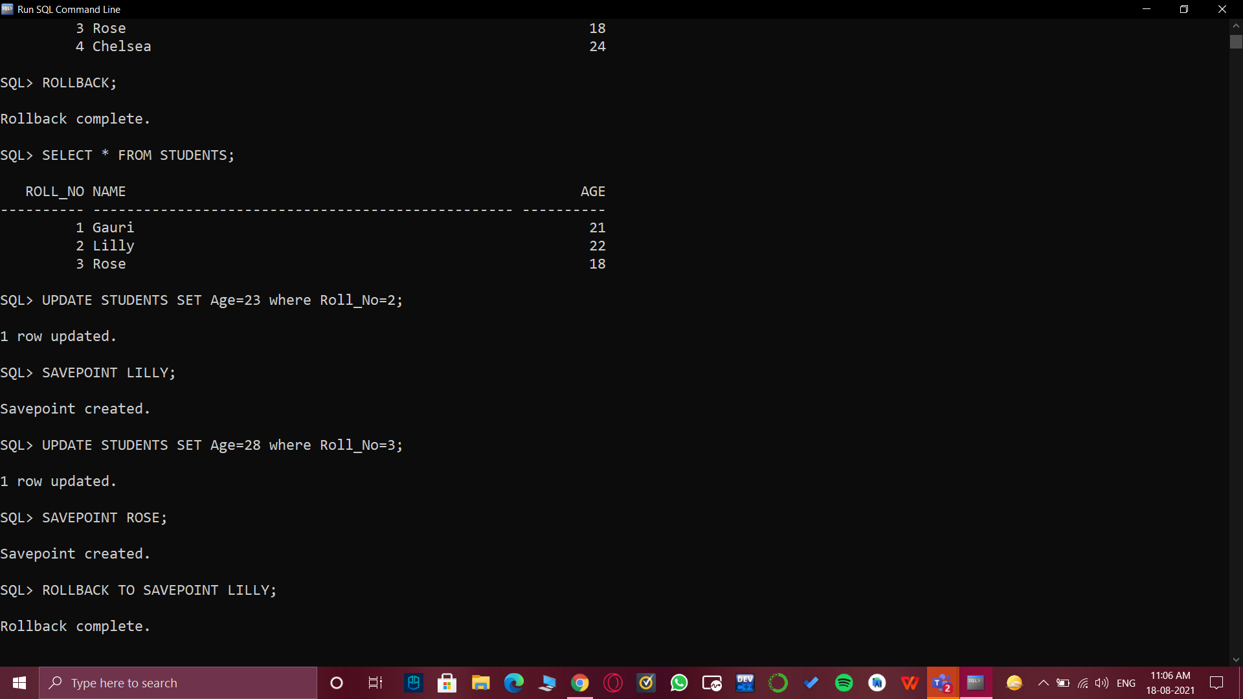

1. Displaying the table after Rollback.

SELECT * FROM STUDENTS;



**Updating values and then creating SAVEPOINT and Rolling back to the Savepoint:**

1. UPDATE STUDENTS SET Age=23 where Roll_No=2;

SAVEPOINT LILLY;

UPDATE STUDENTS SET Age=28 where Roll_No=3;

SAVEPOINT ROSE;



1. Rollback to Savepoint and displaying the table.

ROLLBACK TO SAVEPOINT LILLY;

SELECT * FROM STUDENTS;

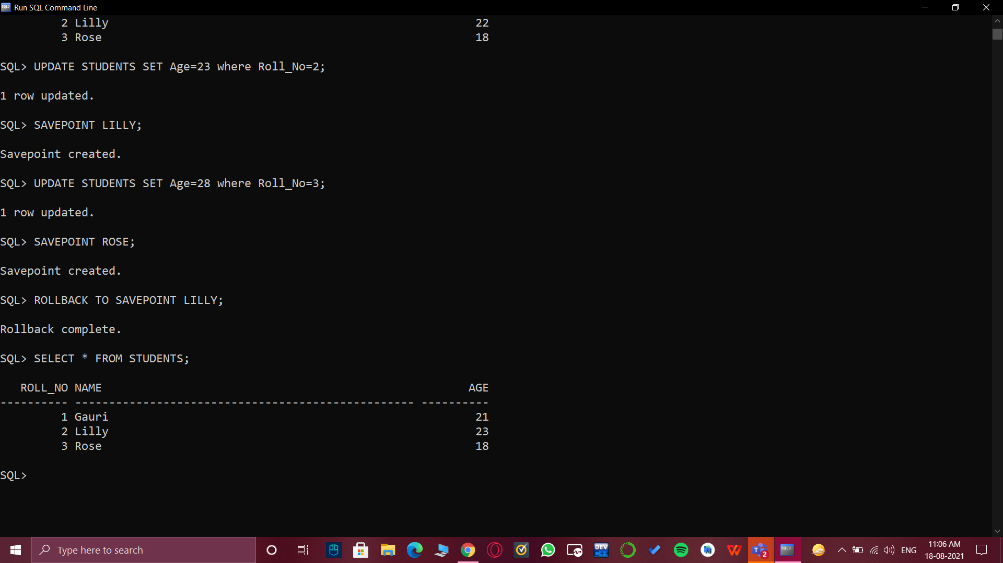

**Revoke the privileges of the created user:**

1. REVOKE CREATE TABLE FROM BETA;



1. **Result/Output/Writing Summary:**

* Successfully created a new user.
* Successfully implemented DCL Commands: Grant and Revoke.
* Successfully created a table on SQL command line.
* Successfully implemented TCL Commands: Commit, Rollback and Savepoint to the new user.
* Successfully understood the working of DCL and TCL commands.

# Learning outcomes (What I have learnt):

* Create new user in SQL.
* How to create table on SQL Command Line.
* DCL and TCL Commands.
* How to implement Grant, Revoke, Commit,Rollback and Savepoint command and returned their outcomes.

**Evaluation Grid (To be created as per the SOP and Assessment guidelines by the faculty):**

|  |  |  |  |
| --- | --- | --- | --- |
| Sr. No. | Parameters | Marks Obtained | Maximum Marks |
| 1. |  |  |  |
| 2. |  |  |  |
| 3. |  |  |  |